NAME: G.Ayyappa venkata sai

Reg no: 192372111

Course : Theory of computations (CSA1303)

Exercise 1
Write a C program to simulate a Deterministic Finite Automata (DFA) for the given language representing strings that start with a and end with a
Code:
#include <stdio.h>
#include <string.h>
int main() {
char str[100];
scanf("%s", str);
int n = strlen(str);
if (str[0] == 'a' && str[n - 1] == 'a')
printf("Accepted");
else
printf("Rejected");
return 0;
}

Output:

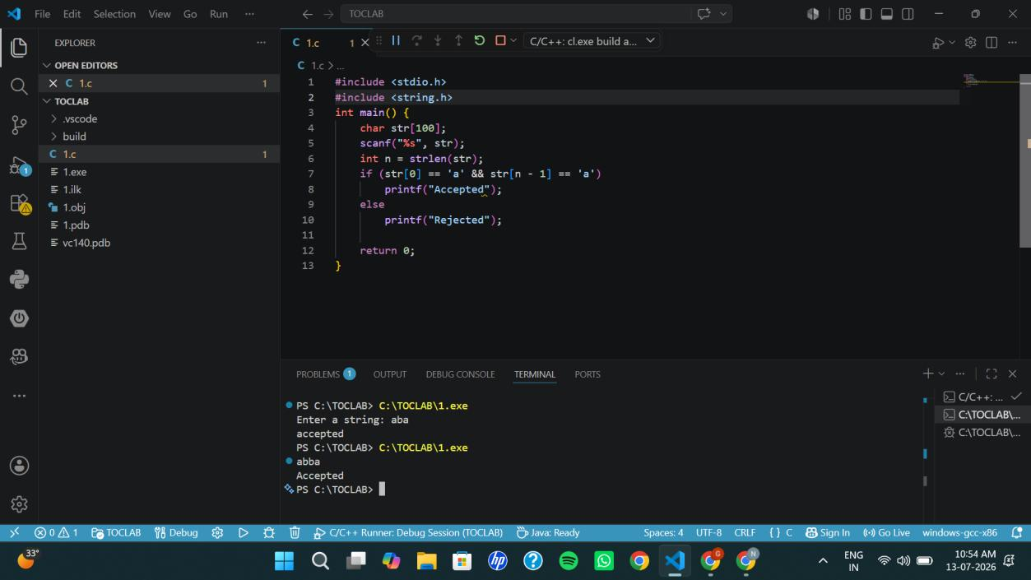

Exercise 2
Write a C program to simulate a Deterministic Finite Automata (DFA) for the given language representing strings that start with 0 and end with 1
Code:
#include <stdio.h>
#include <string.h>
int main() {
char str[100];
scanf("%s", str);
int n = strlen(str);
if (str[0] == '0' && str[n - 1] == '1')
printf("Accepted");
else
printf("Rejected");
return 0;
}
Output:
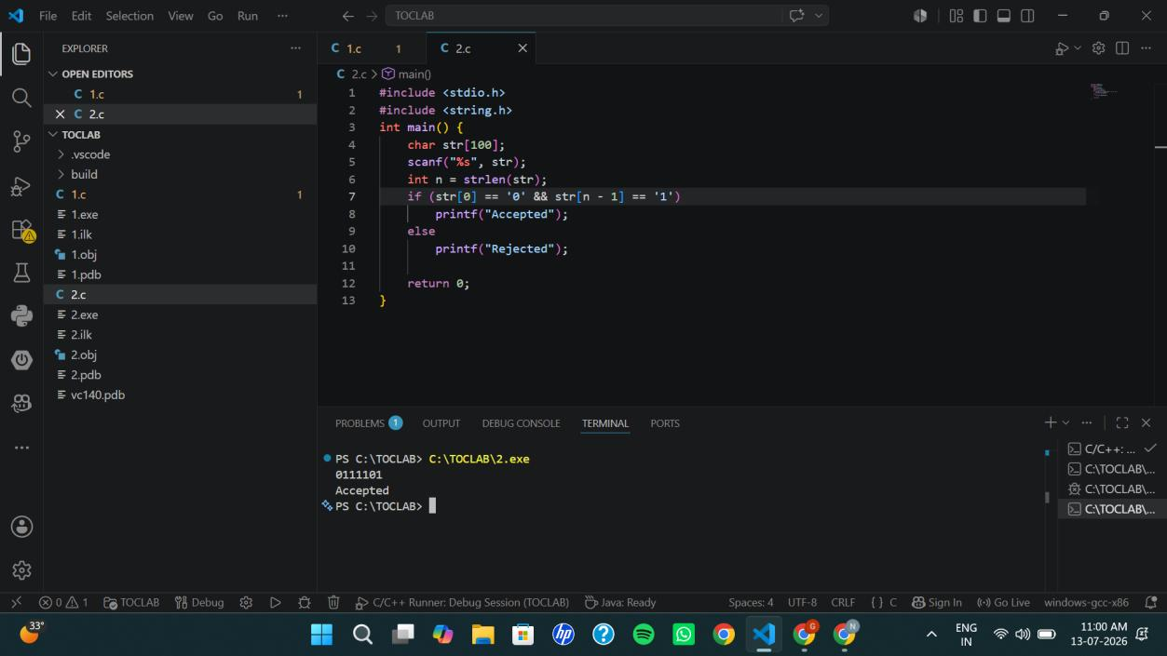

Exercise 3
Write a C program to check whether a given string belongs to the language defined by a Context Free Grammar (CFG)
S → 0A1 A → 0A | 1A | ε
Code:
#include <stdio.h>
#include <string.h>
int main() {
char str[100];
int len;
printf("Enter a string: ");
scanf("%s", str);
len = strlen(str);
if (len >= 2 && str[0] == '0' && str[len - 1] == '1')
printf("String Accepted");
else
printf("String Rejected");
return 0;
}
Output:
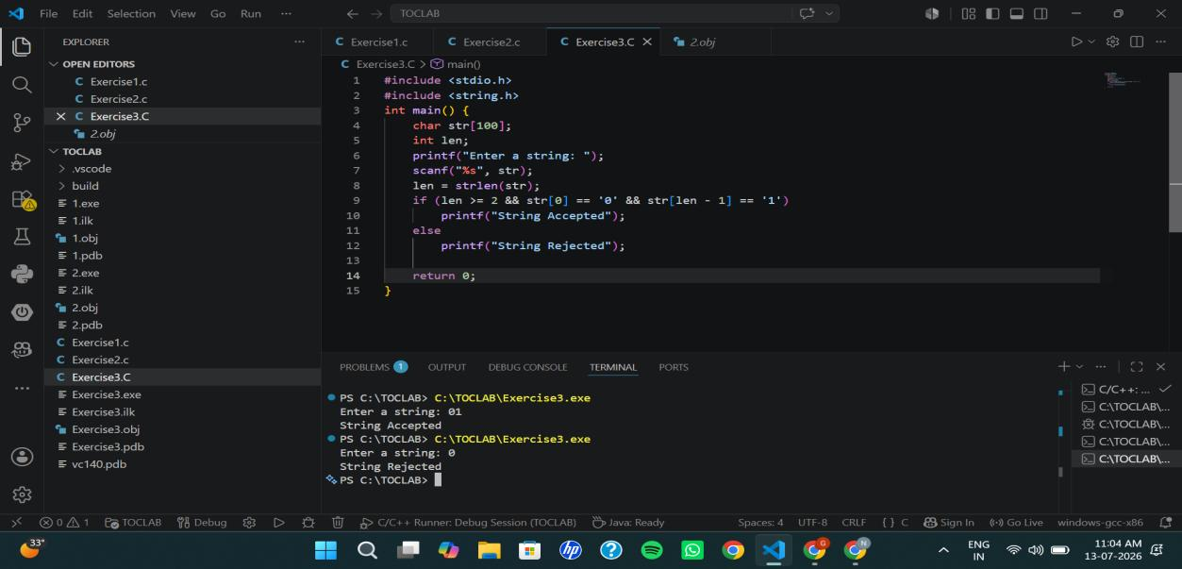

Exercise 4
Write a C program to check whether a given string belongs to the language defined by a Context Free Grammar (CFG)
S → 0S0 | 1S1 | 0 | 1 | ε
Code:
#include <stdio.h>
#include <string.h>
int main() {
char str[100];
int i, len, flag = 1;
printf("Enter a binary string: ");
scanf("%s", str);
len = strlen(str);
for (i = 0; i < len / 2; i++) {
if (str[i] != str[len - i - 1]) {
flag = 0;
break;
}
}
if (flag)
printf("String Accepted");
else
printf("String Rejected");
return 0;
}
Output:
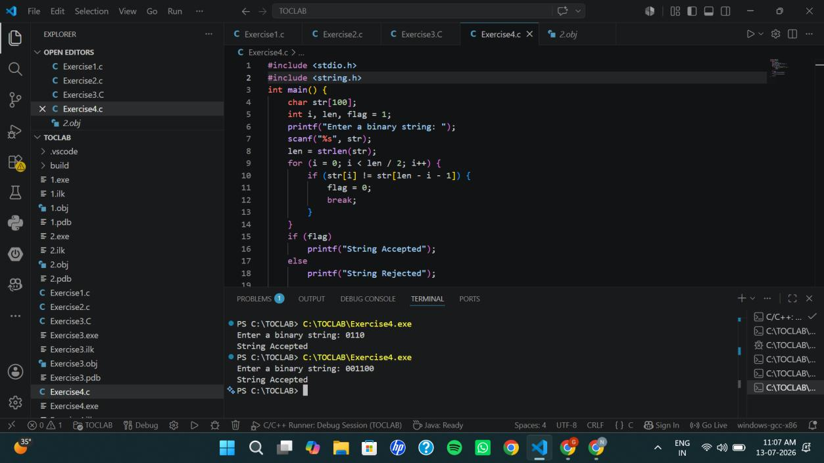

Exercise 5
Write a C program to check whether a given string belongs to the language defined by a Context Free Grammar (CFG)
S → 0S0 | A A → 1A | ε
Code:
#include <stdio.h>
#include <string.h>
int main() {
char s[100];
int i, n, count = 0;
printf("Enter string: ");
scanf("%s", s);
n = strlen(s);
while (s[count] == '0')
count++;
for (i = count; i < n - count; i++) {
if (s[i] != '1') {
printf("Rejected");
return 0;
}
}
if (count * 2 <= n)
printf("Accepted");
else
printf("Rejected");
return 0;
}
Output:
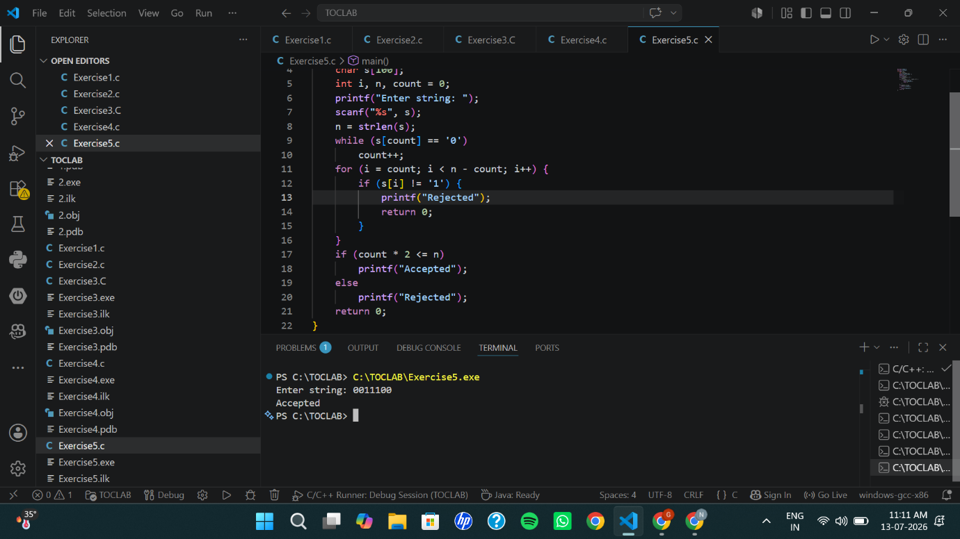

Exercise 6
Write a C program to check whether a given string belongs to the language defined by a Context Free Grammar (CFG)
S → 0S1 | ε
Code:
#include <stdio.h>
#include <string.h>
int main() {
char s[100];
int i, n;
scanf("%s", s);
n = strlen(s);
for(i = 0; i < n/2; i++)
if(s[i] != '0' || s[n-i-1] != '1')
break;
if(i == n/2 && n%2 == 0)
printf("Accepted");
else
printf("Rejected");
}
Output:
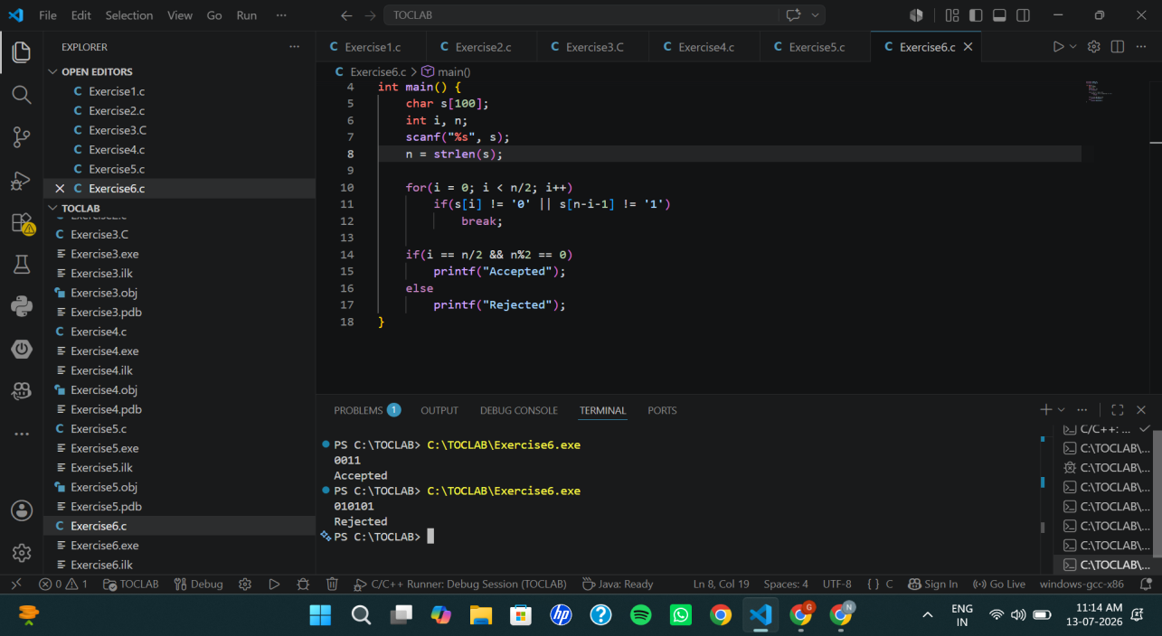

Exercise 7
Write a C program to check whether a given string belongs to the language defined by a Context Free Grammar (CFG)
S → A101A, A → 0A | 1A | ε
Code:
#include <stdio.h>
#include <string.h>
int main() {
char s[100];
scanf("%s", s);
if (strstr(s, "101"))
printf("Accepted");
else
printf("Rejected");
return 0;
}
Output:
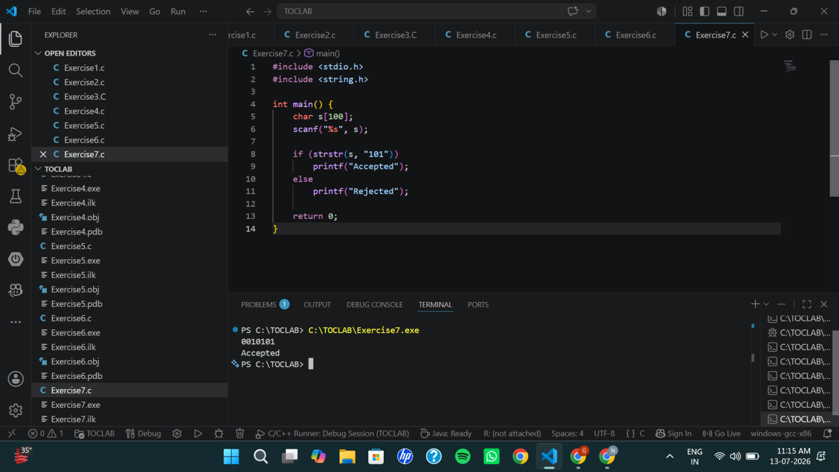

Exercise 8:

Write a C program to simulate a Non-Deterministic Finite Automata (NFA) for the

given languagerepresenting strings that start with b and end with a

Code:

#include <stdio.h>

#include <string.h>

int main() {

char str[100];

int len;

printf("Enter the string: ");

scanf("%s", str);

len = strlen(str);

// NFA Acceptance Condition

if (len > 0 && str[0] == 'b' && str[len - 1] == 'a')

printf("String Accepted by NFA\n");

else

printf("String Rejected by NFA\n");

return 0;

}

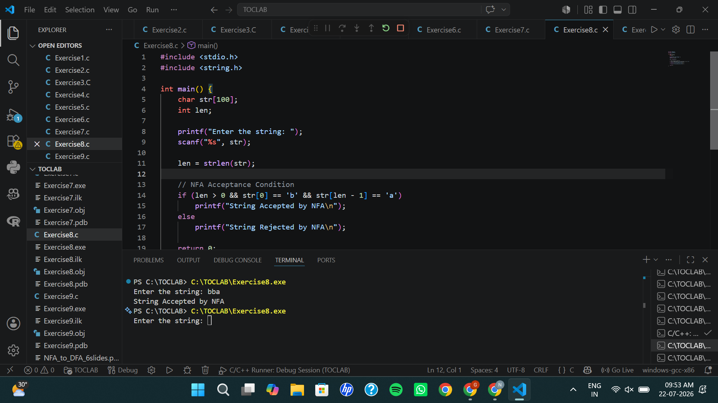
Output:

Exercise 9
Write a C program to simulate a Non-Deterministic Finite Automata (NFA) for the
given languagerepresenting strings that start with o and end with 1
Code:

#include <stdio.h>

#include <string.h>

int main() {

char str[100];

int len;

printf("Enter the string: ");

scanf("%s", str);

len = strlen(str);

// NFA Acceptance Condition

if (len > 0 && str[0] == '0' && str[len - 1] == '1')

printf("String Accepted by NFA\n");

else

printf("String Rejected by NFA\n");

return 0;

}
Output:
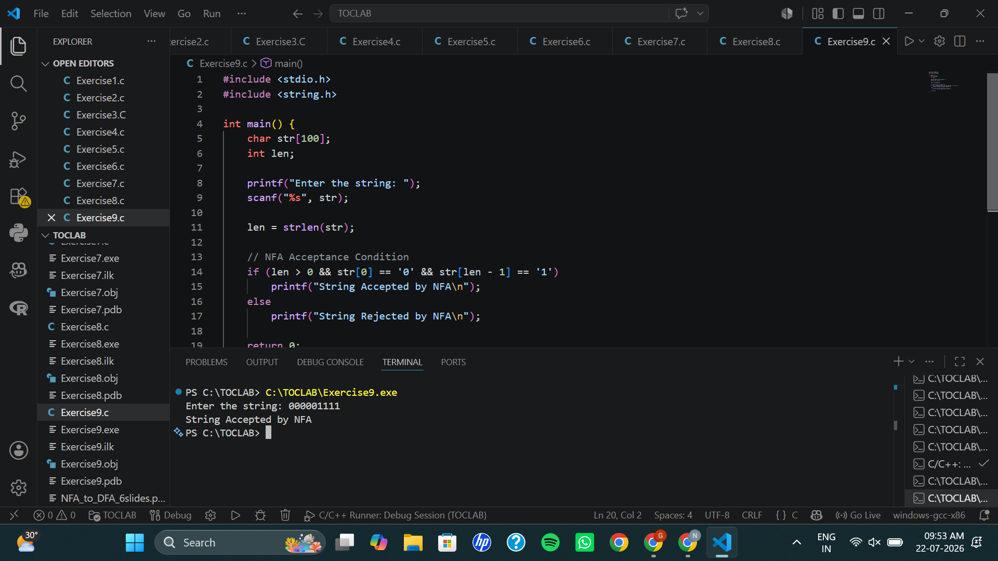

Exercise 10

Write a C program to find ε -closure for all the states in a Non-Deterministic Finite

Automata (NFA) with ε -moves.

Code:

#include <stdio.h>

int main() {

int n, e[10][10];

int i, j;

printf("Enter number of states: ");

scanf("%d", &n);

printf("Enter epsilon transition matrix:\n");

for(i = 0; i < n; i++) {

for(j = 0; j < n; j++) {

scanf("%d", &e[i][j]);

}

}

for(i = 0; i < n; i++) {

printf("\nE-Closure(q%d) = { q%d", i, i);

for(j = 0; j < n; j++) {

if(e[i][j] == 1)

printf(", q%d", j);

}

printf(" }\n");

}

return 0;

}

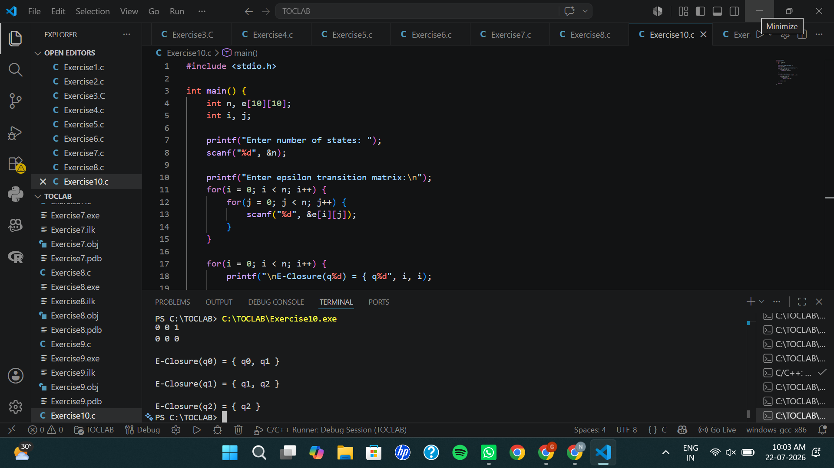
Output:

Exercise 11:

Write a C program to find ε -closure for all the states in a Non-Deterministic Finite

Automata (NFA) with ε -moves.

Code:

#include <stdio.h>

int main() {

int n, e[10][10];

int i, j;

printf("Enter number of states: ");

scanf("%d", &n);

printf("Enter epsilon transition matrix:\n");

for(i = 0; i < n; i++) {

for(j = 0; j < n; j++) {

scanf("%d", &e[i][j]);

}

}

for(i = 0; i < n; i++) {

printf("\nE-Closure(q%d) = { q%d", i, i);

for(j = 0; j < n; j++) {

if(e[i][j] == 1)

printf(", q%d", j);

}

printf(" }\n");

}

return 0;

}

Output

Exercise 12:
Output :

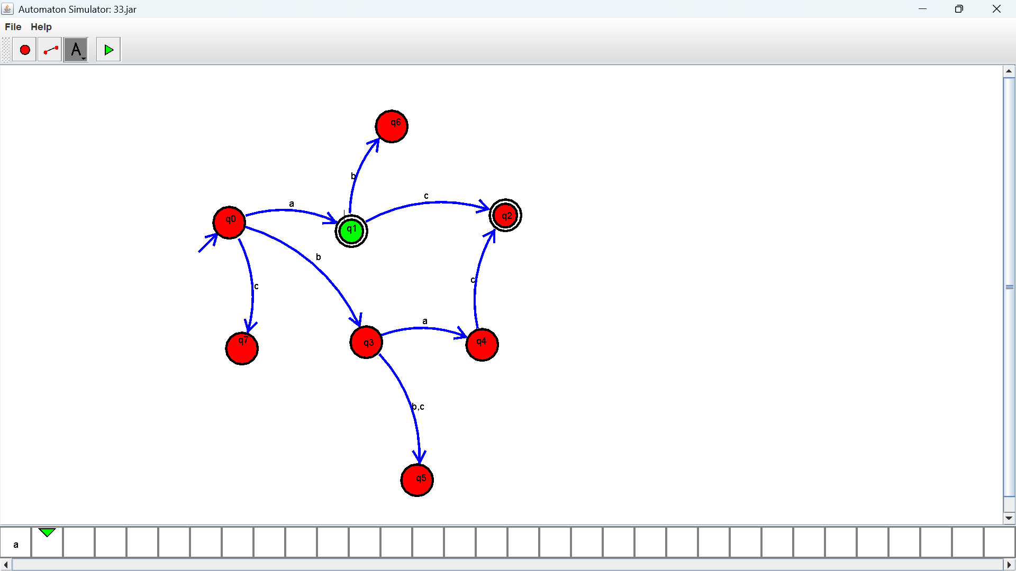

Exercise 13:
Output :
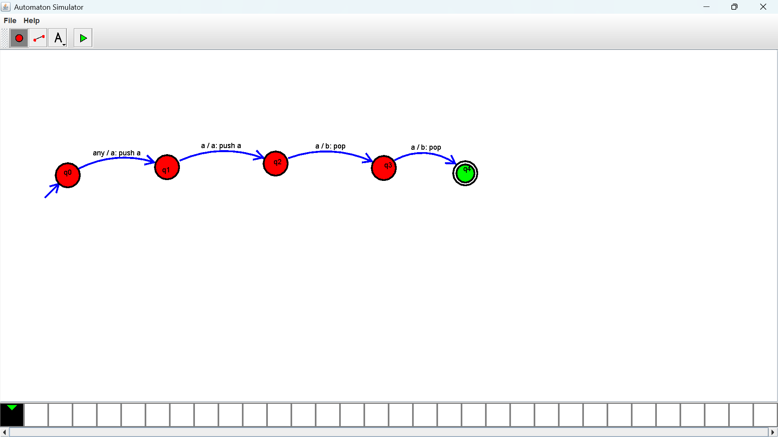

Exercise 14:
Output :

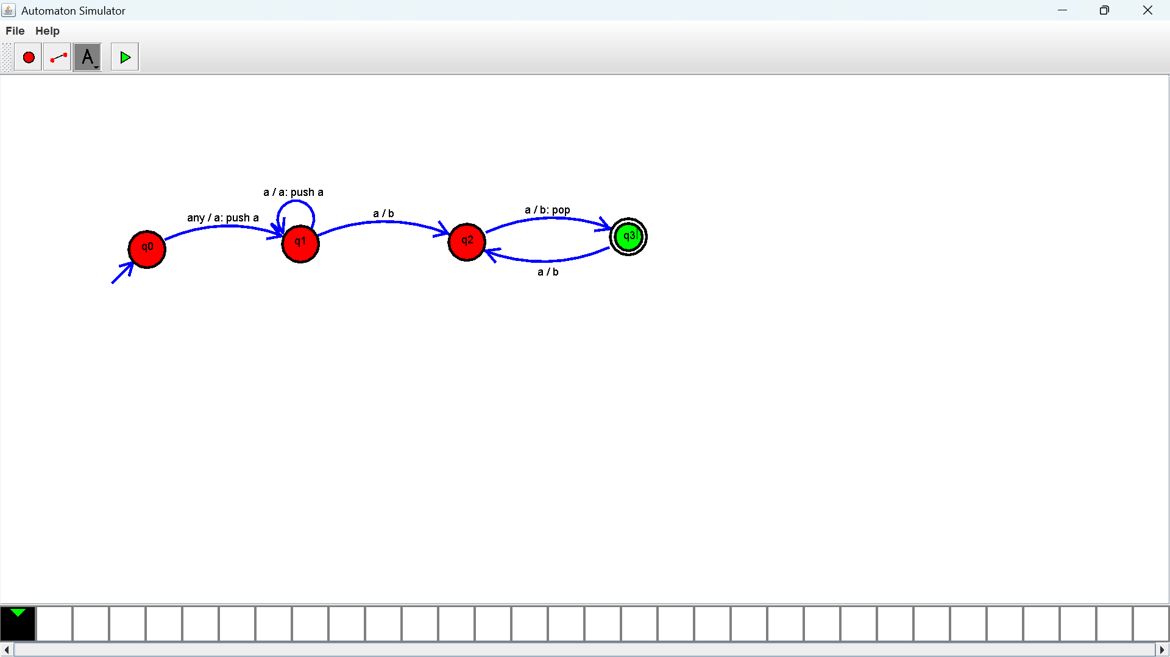

Exercise 15:
Output :
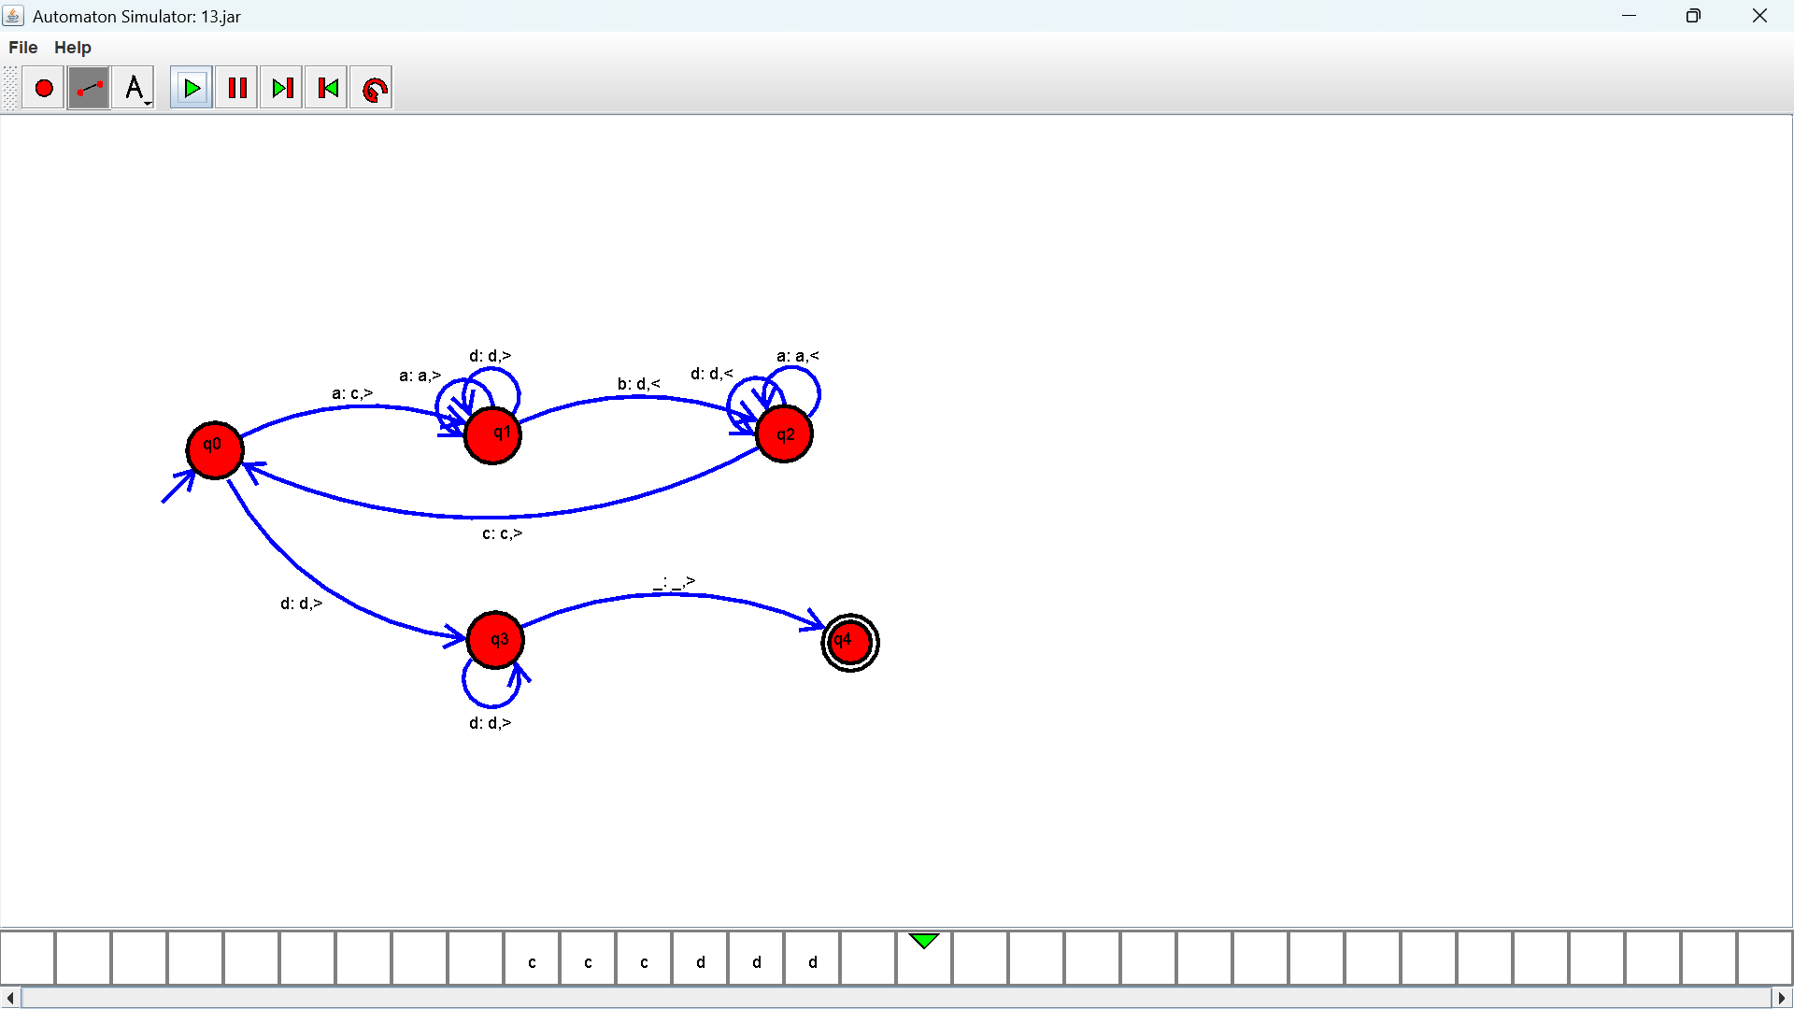

Exercise 16:
Output :
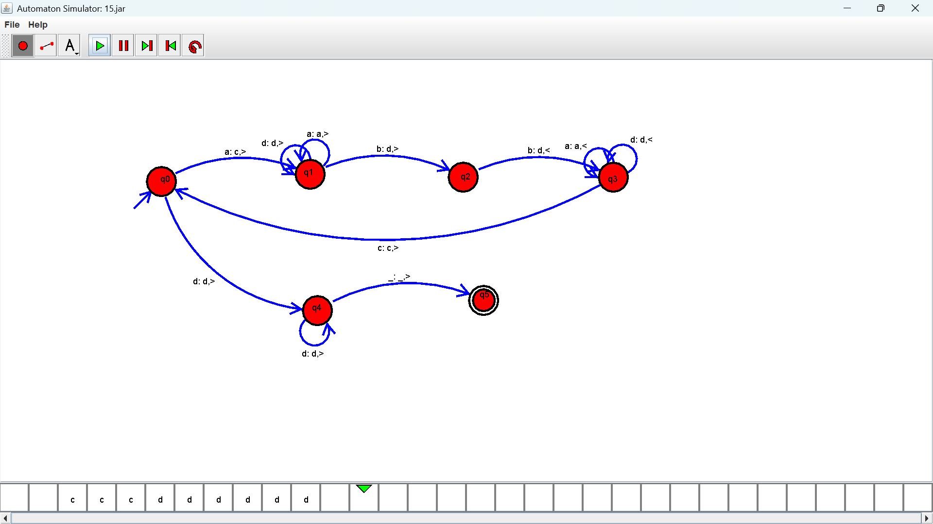

Exercise 17:
Output :
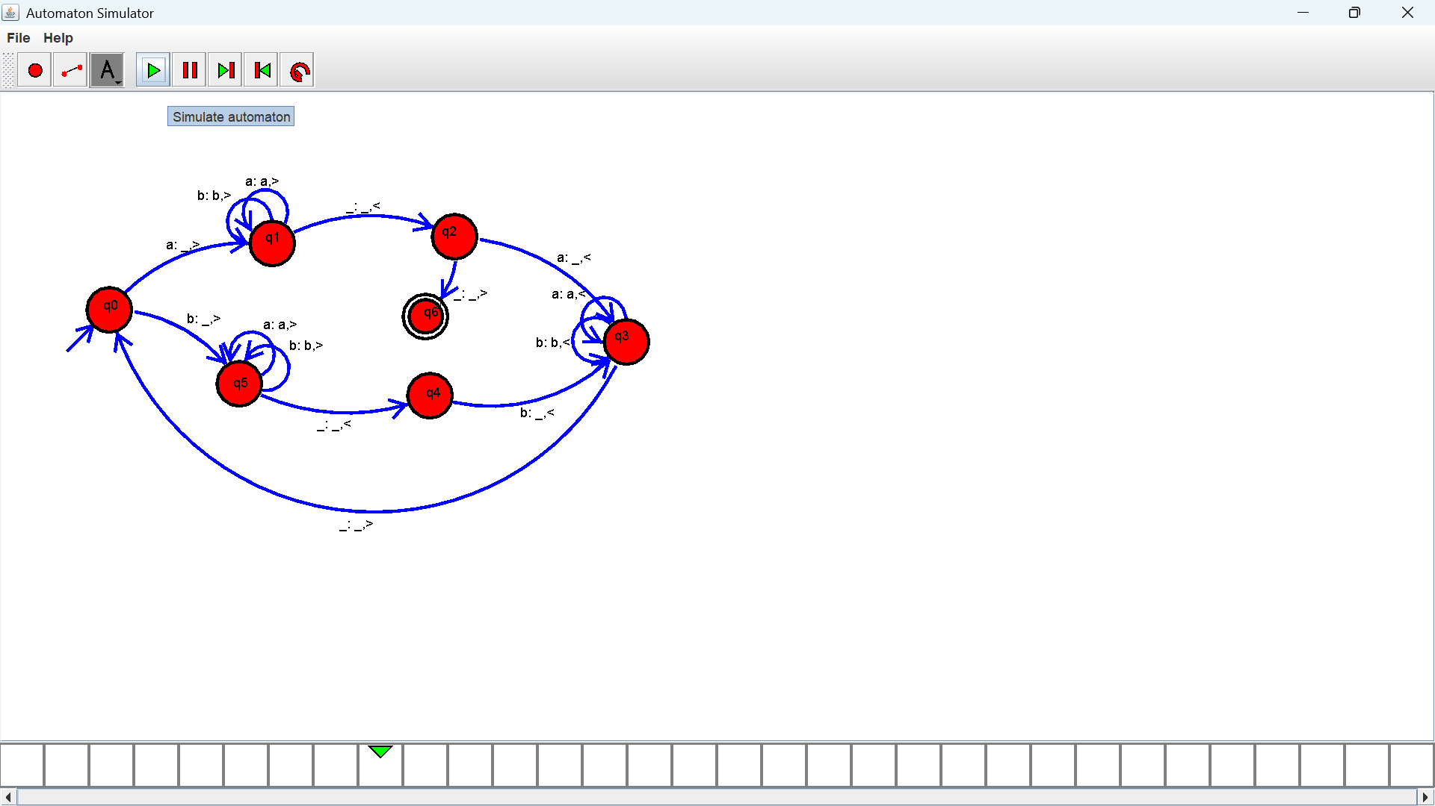

Exercise 18:
Output :
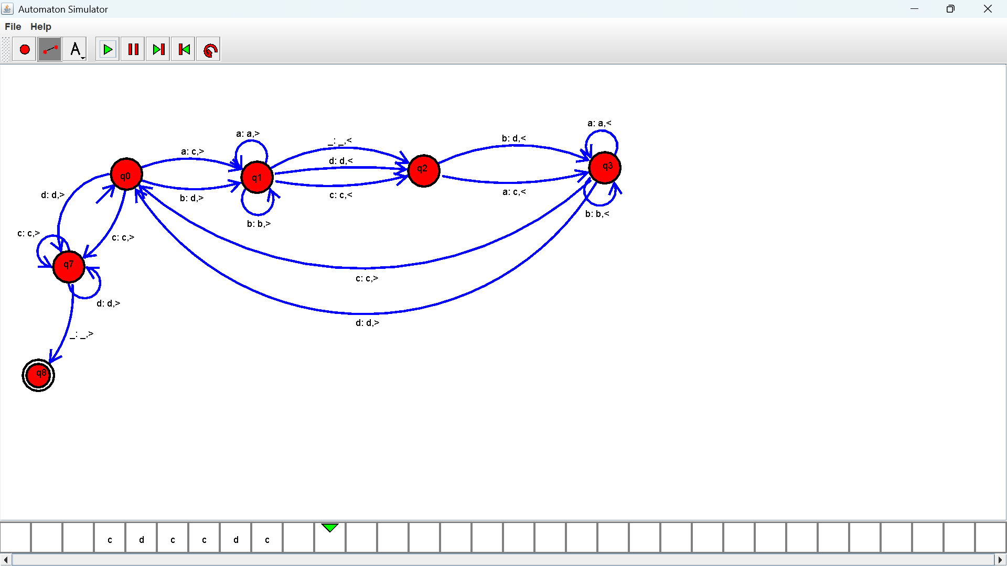

Exercise 19:
Output :
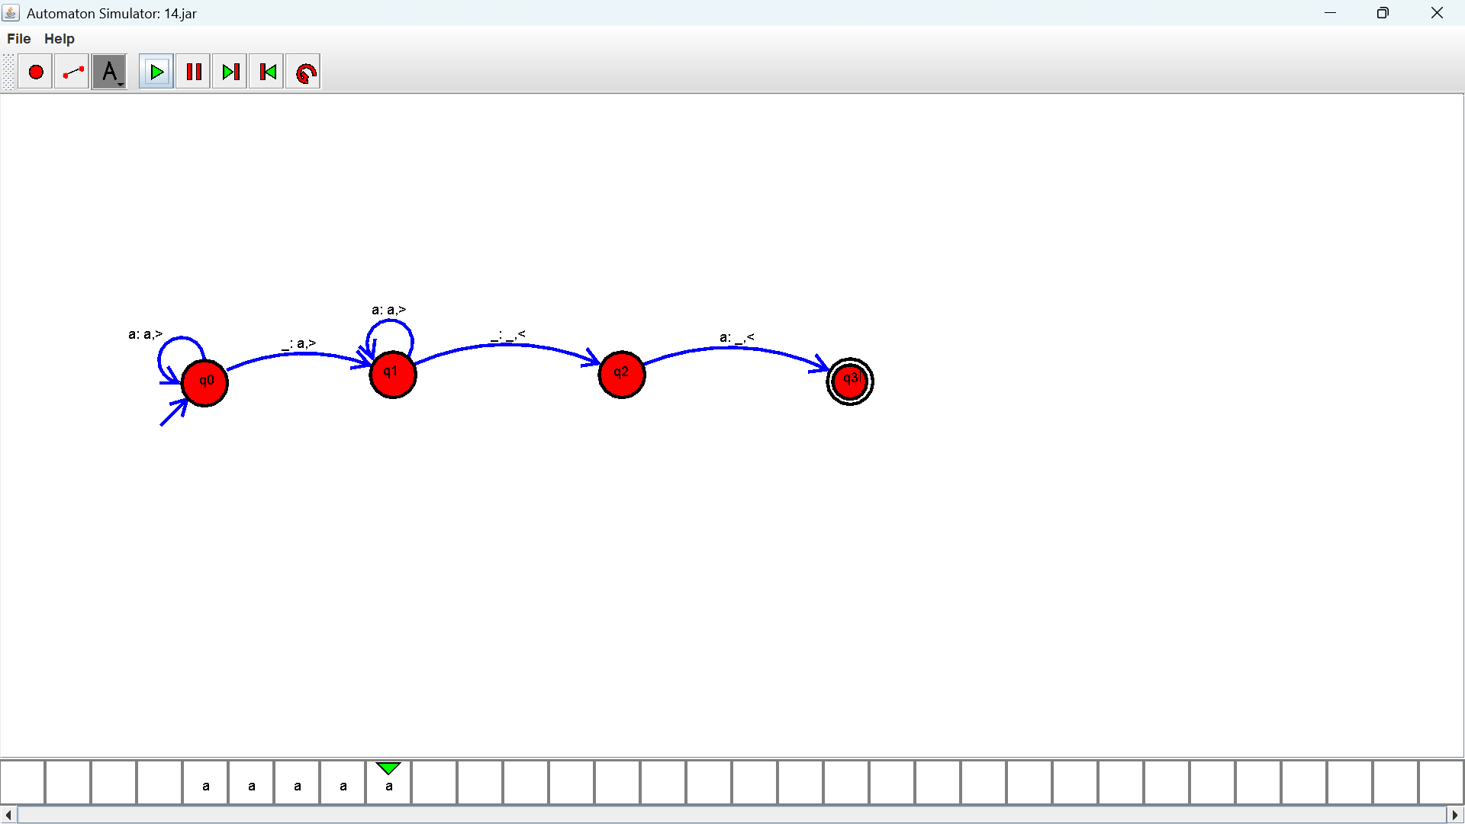
Exercise 20:
Output :

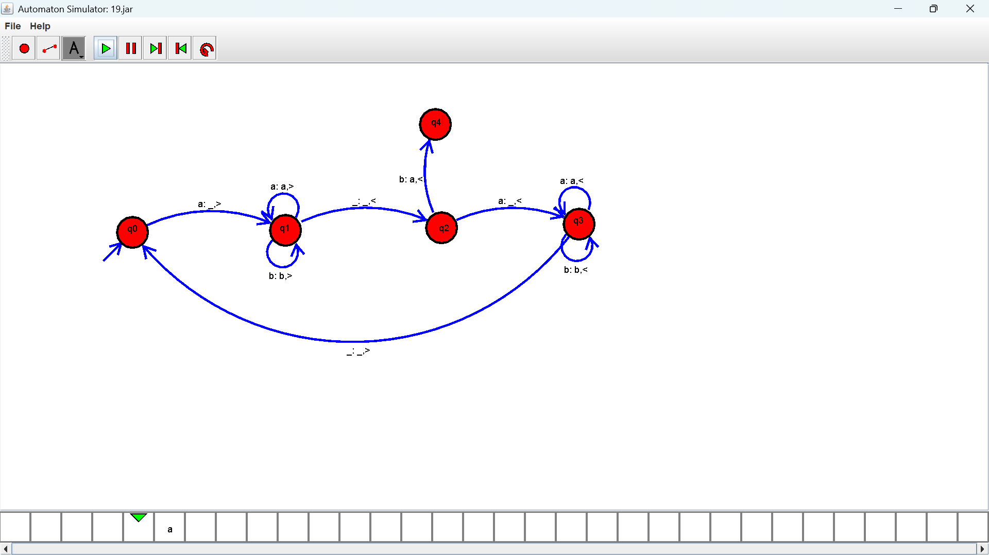

Exercise 21:
Output :
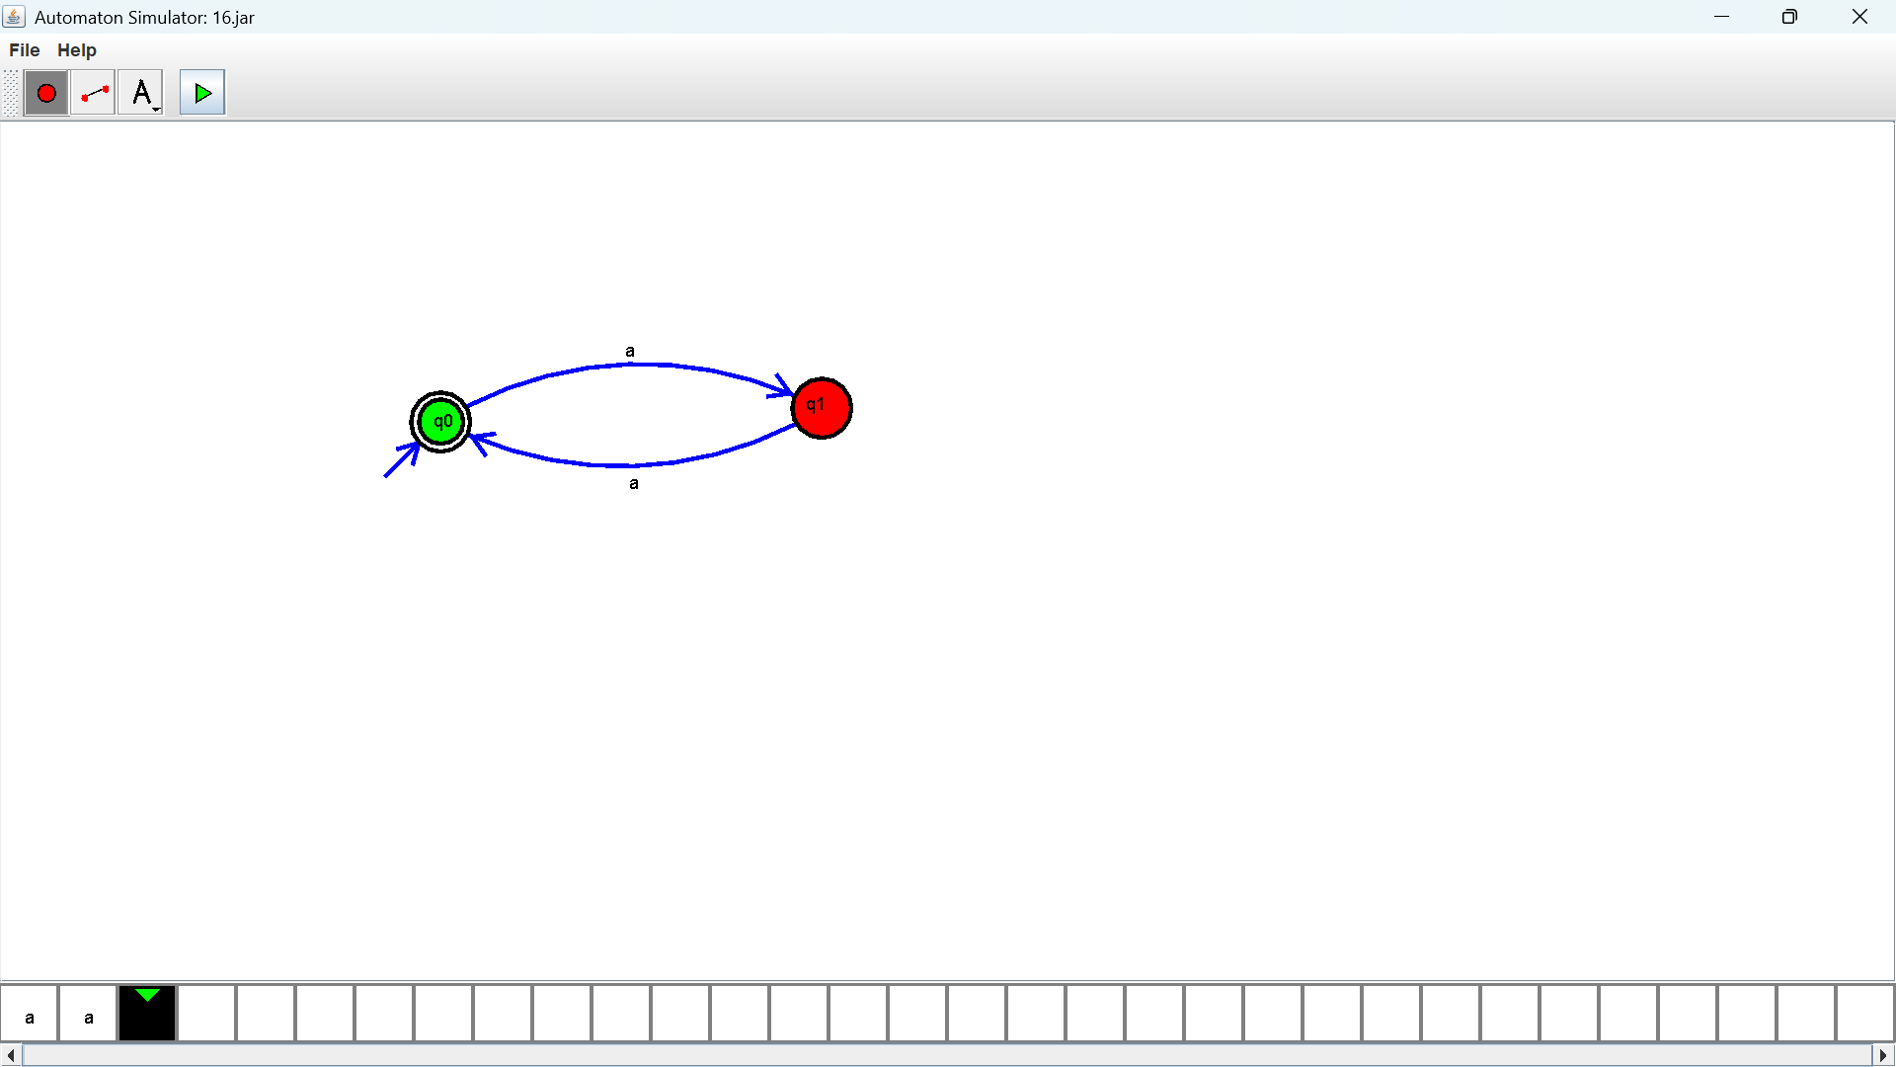

Exercise 22:
Output :
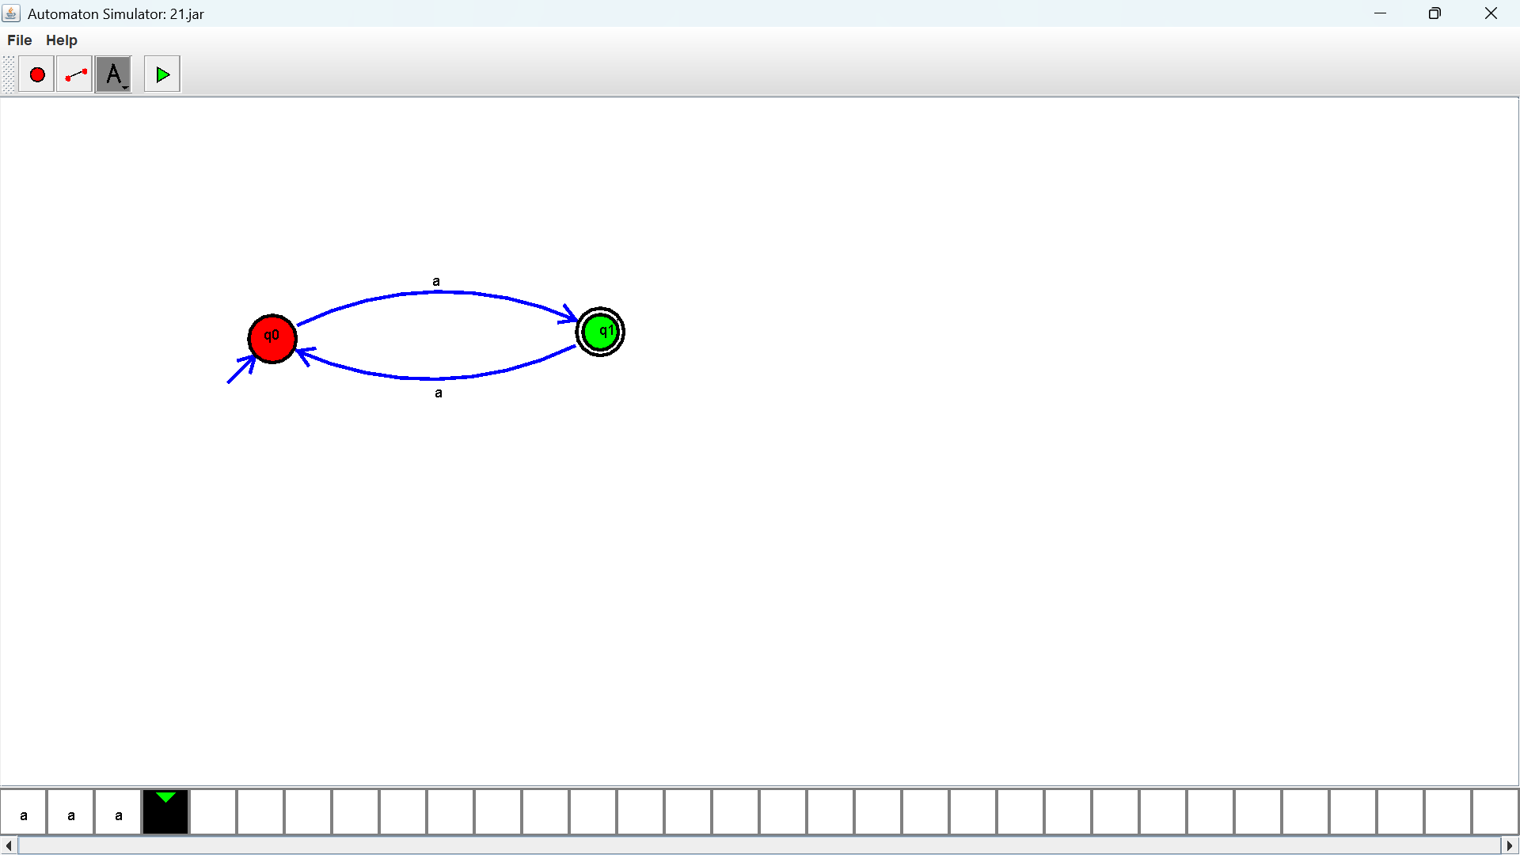

Exercise 23:
Output :
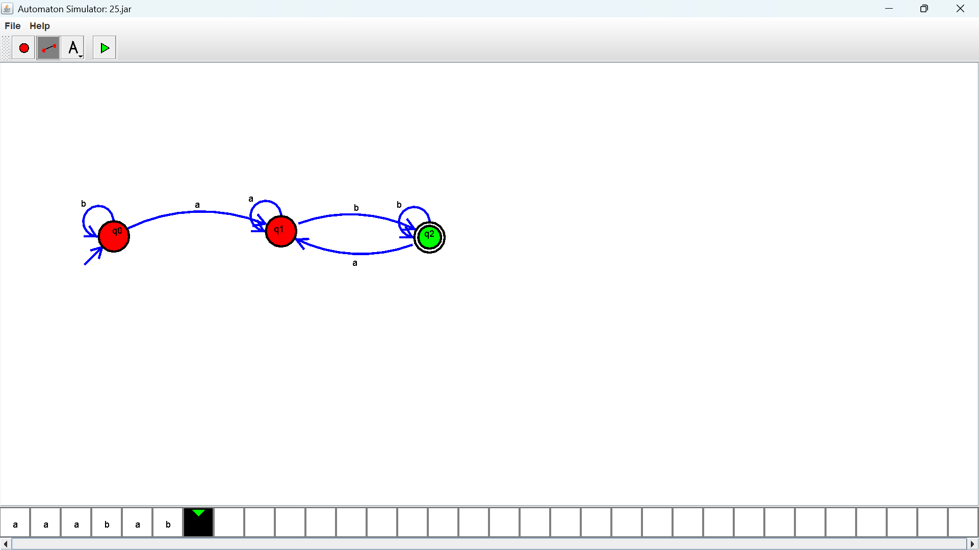

Exercise 24:
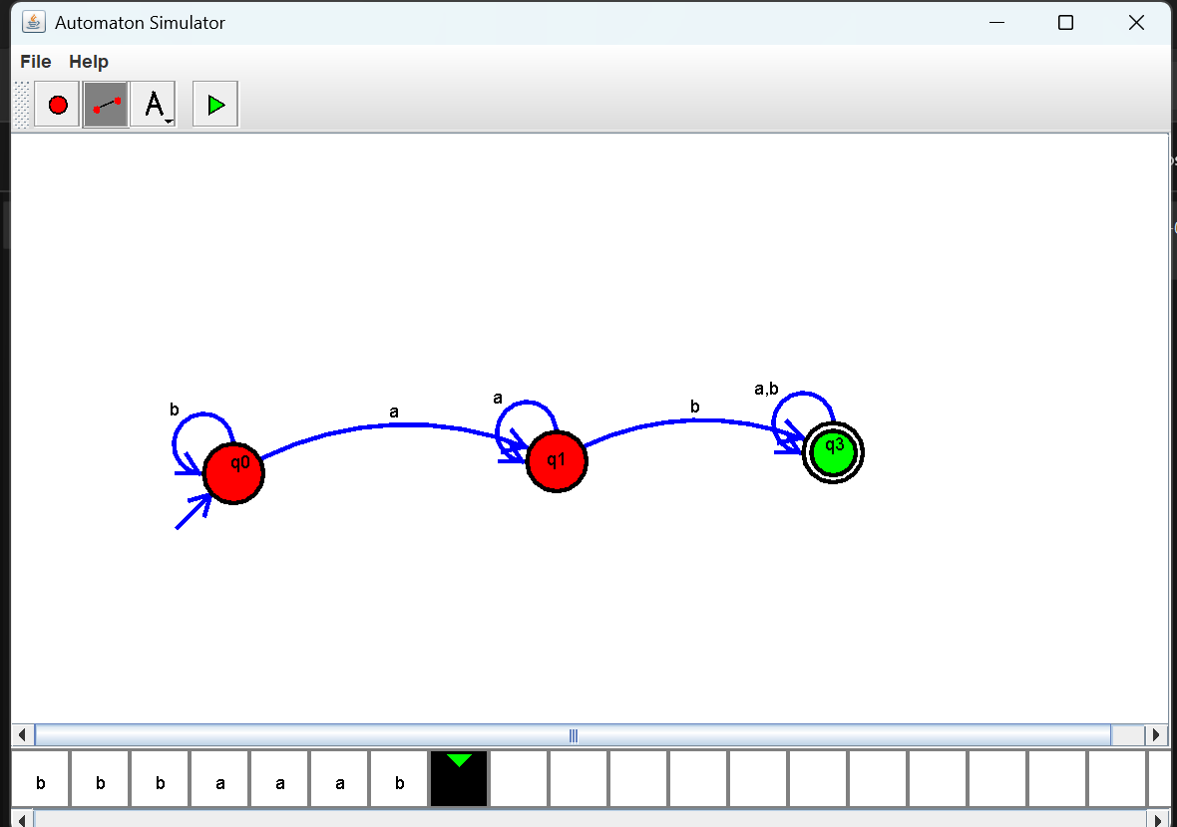
Output :

Exercise 25:
Output :
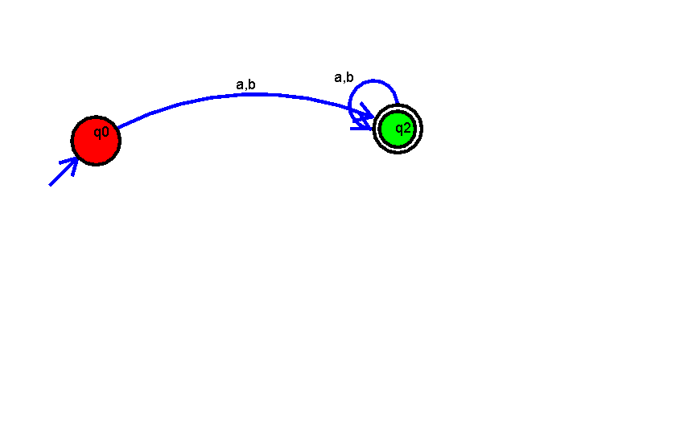

Exercise 26:
Output :
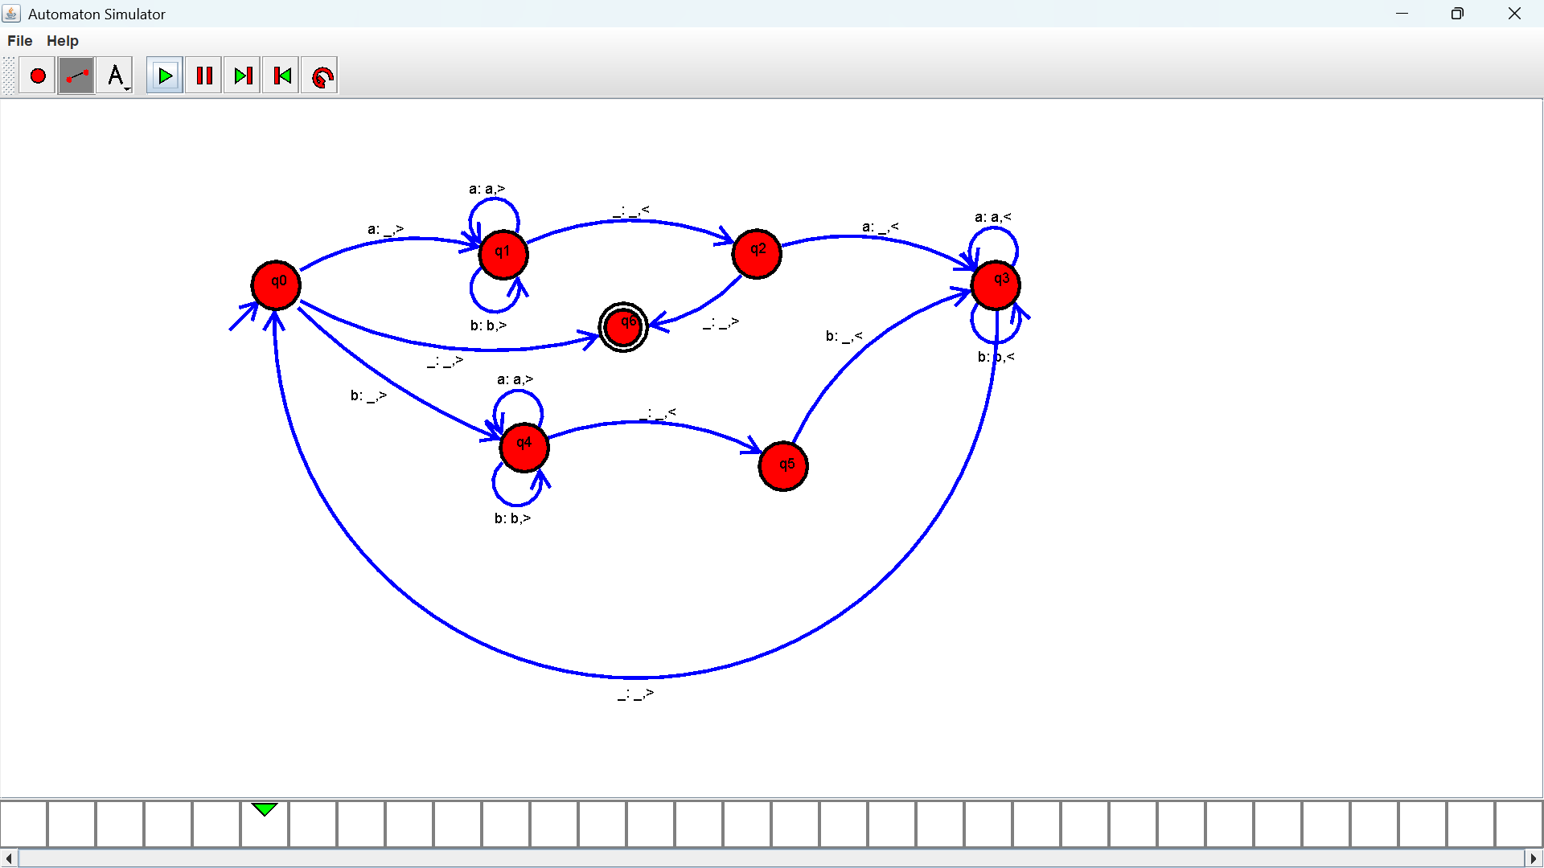

Exercise 27:
Output :

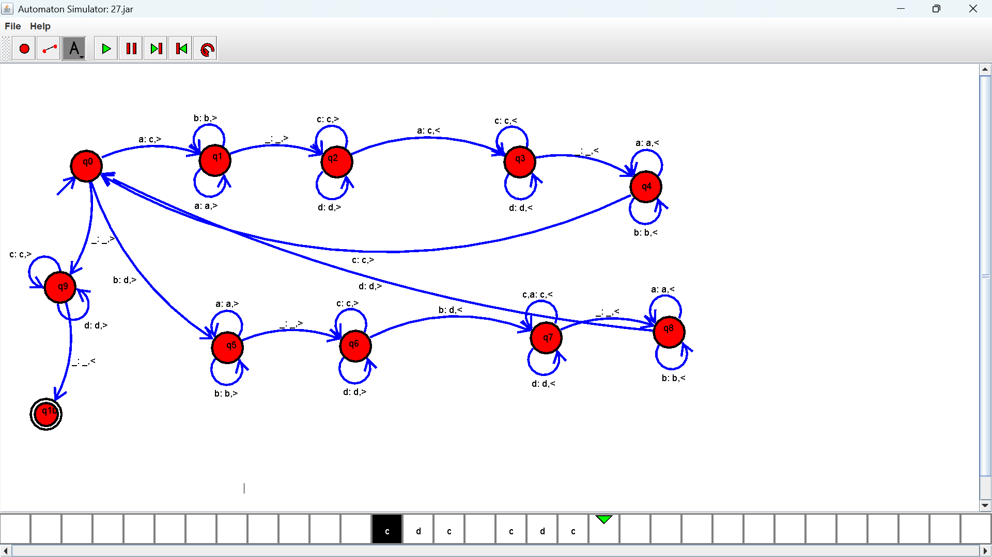

Exercise 28:
Output :
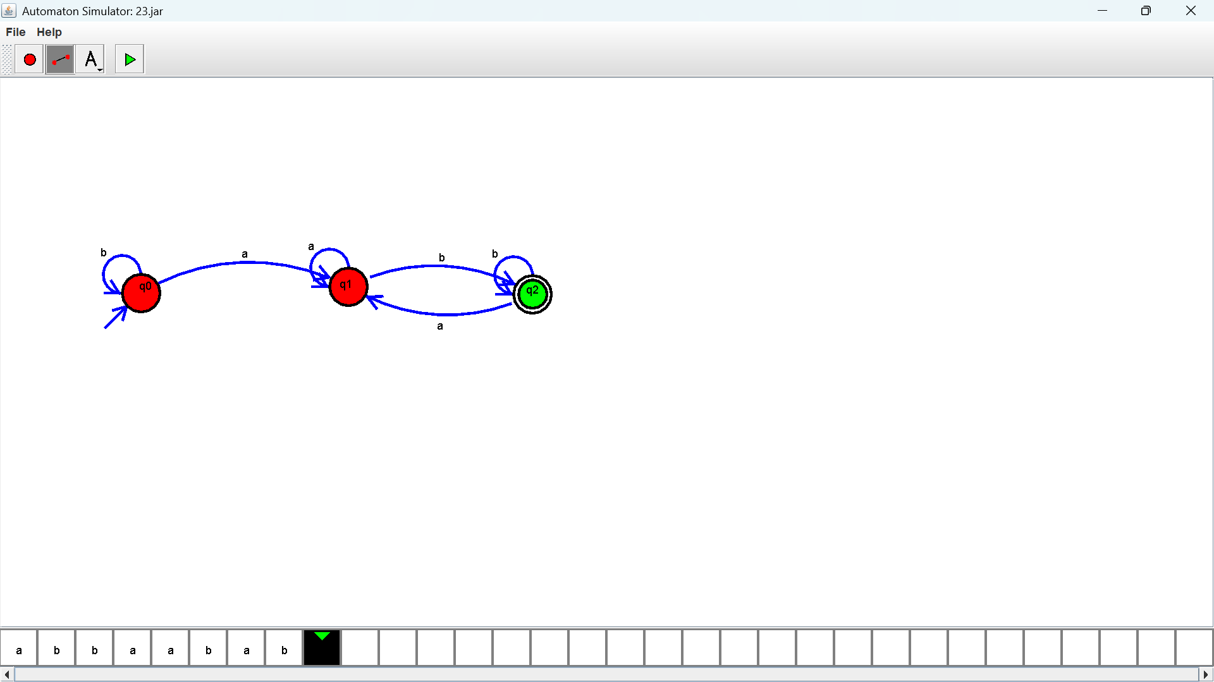

Exercise 29:
Output :

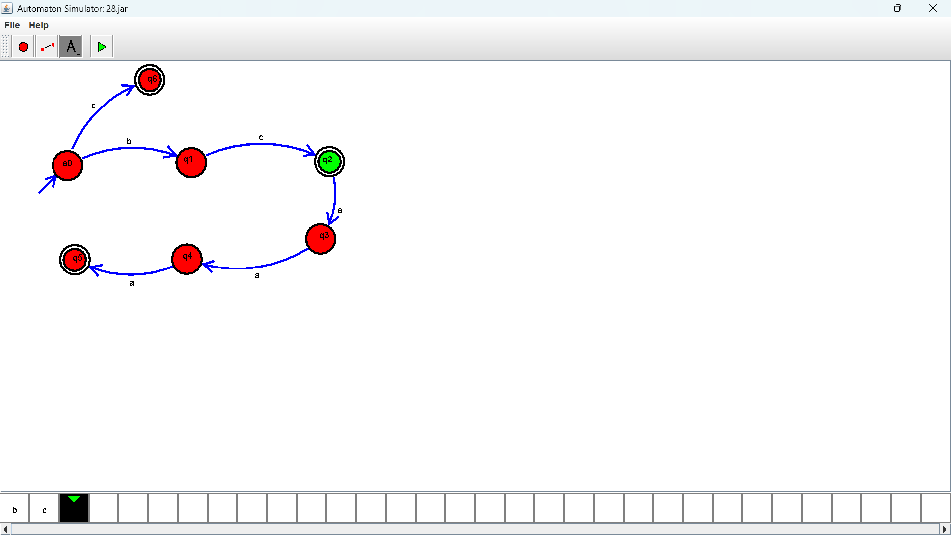

Exercise 30:
Output :
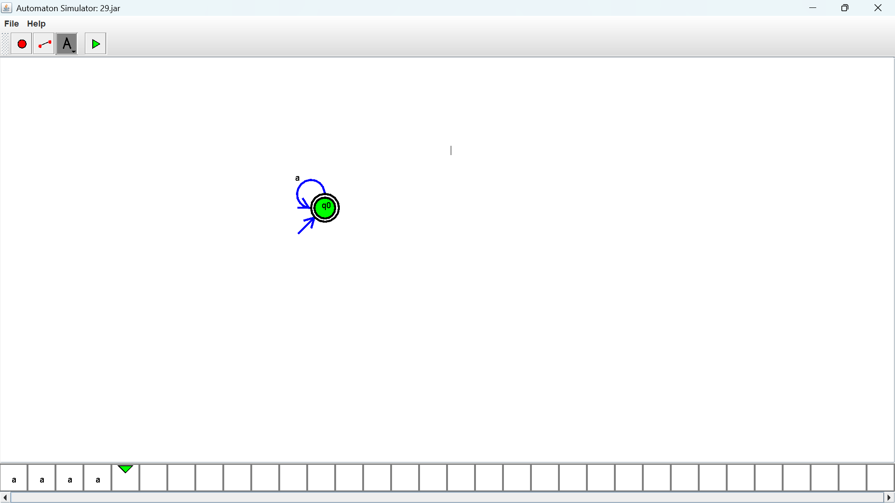

Exercise 31:
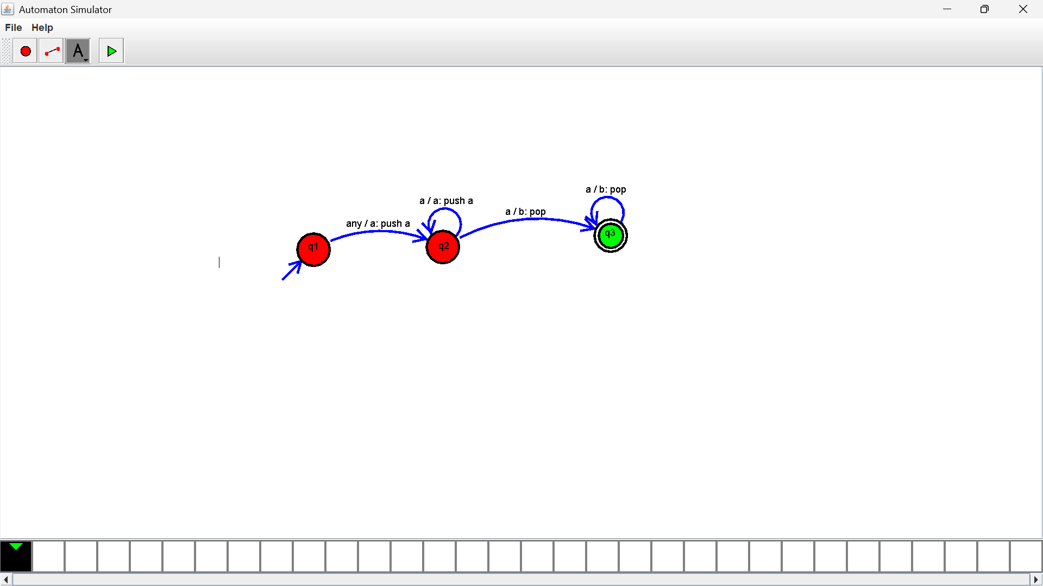
Output :

Exercise 32:
Output :


Exercise 33:
Output :
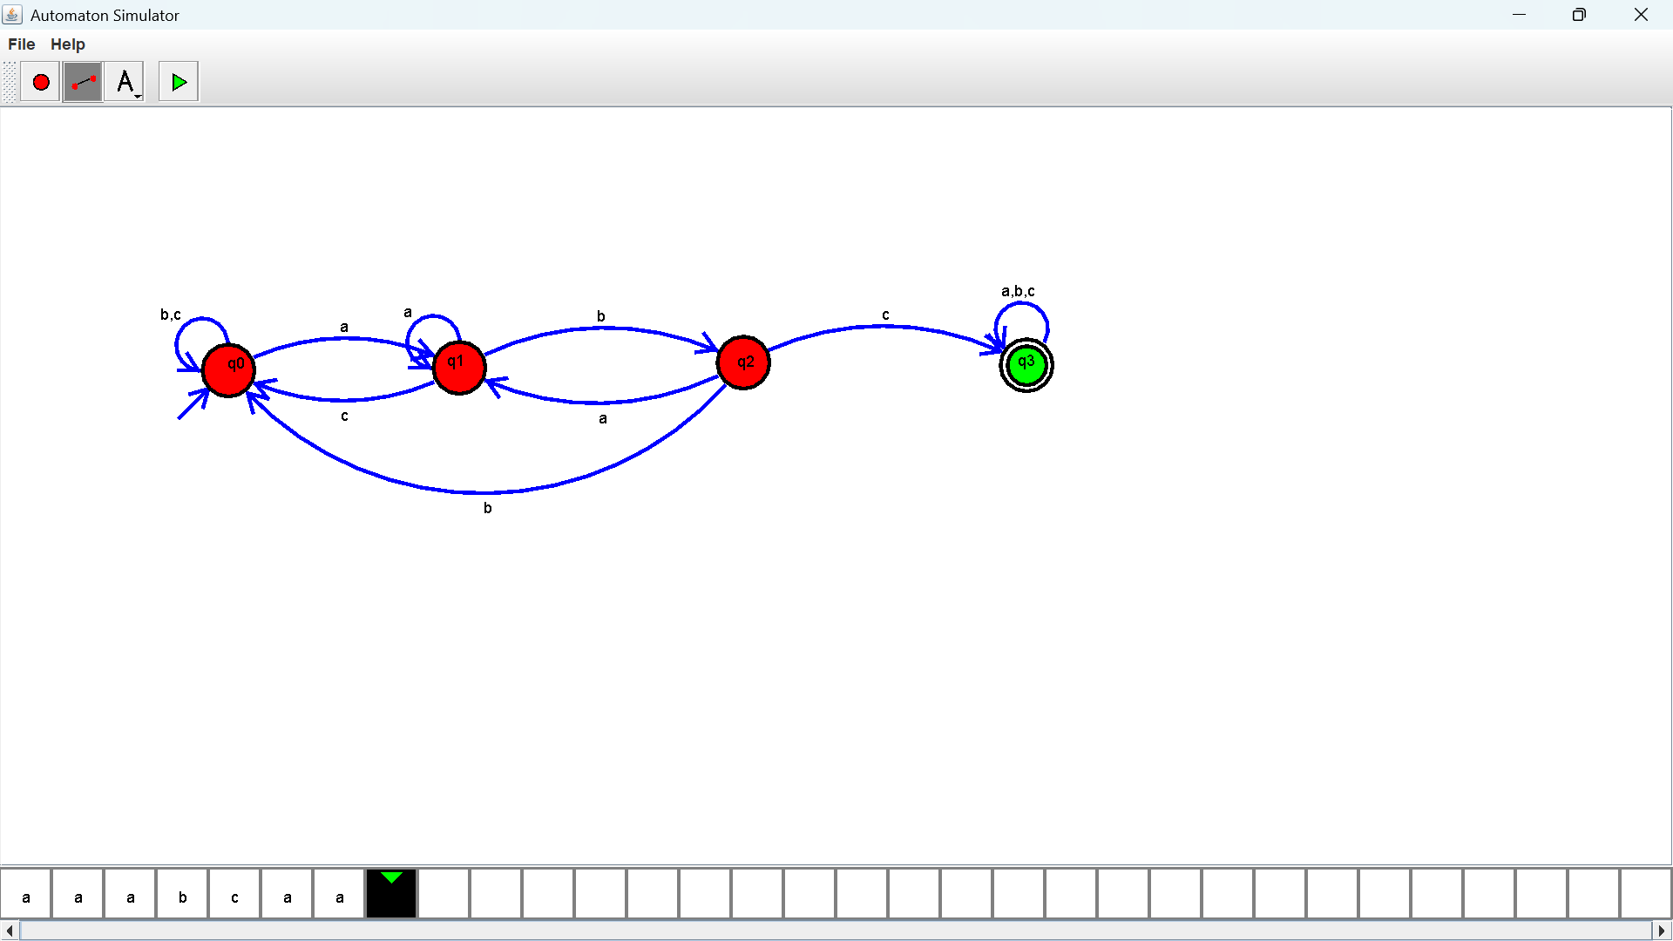
Exercise 34:
Output :
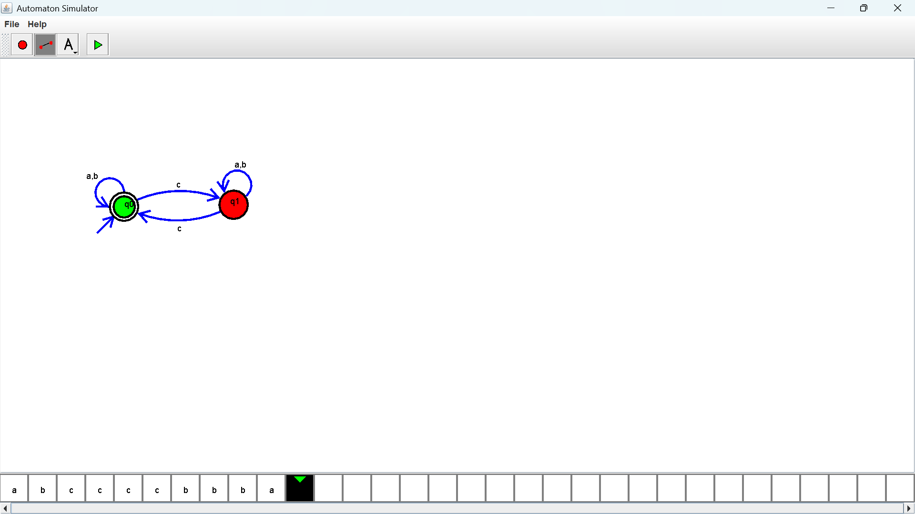

Exercise 35:
Output :
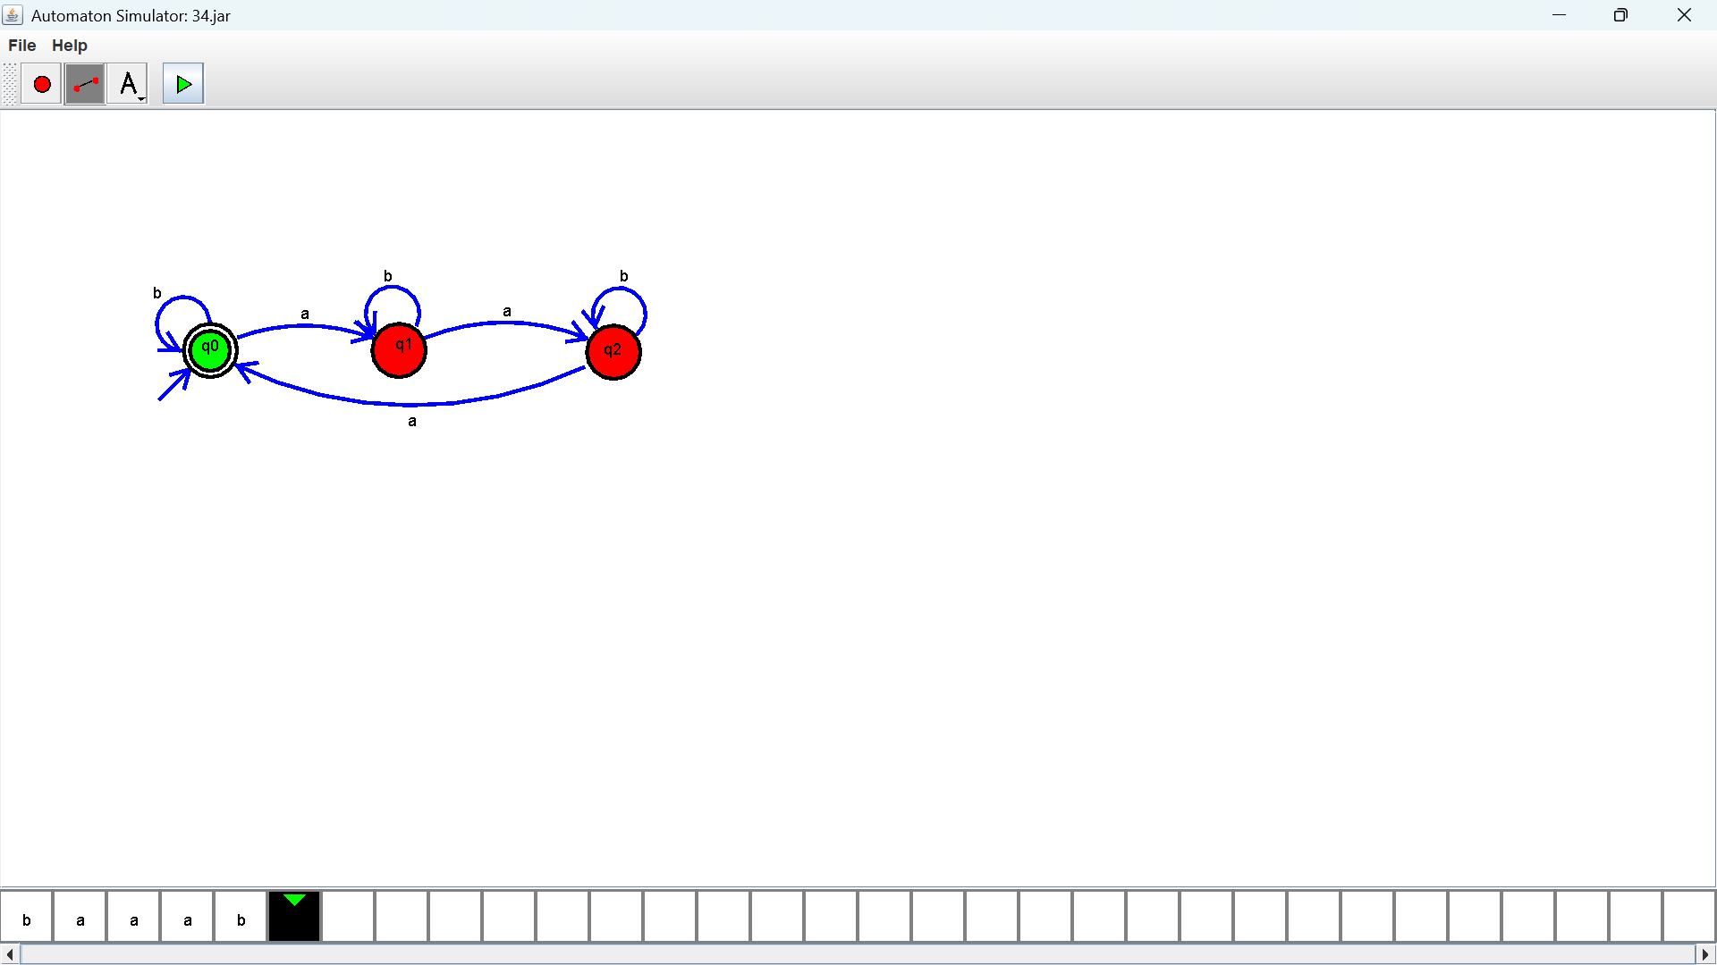
Exercise 36:
Output :
Exercise 37:
Output :
Exercise 38:
Output :
Exercise 309:
Output :
Exercise 40:
Output :

